**Assignment 8: Implement Backward Chaining Algorithm**

**Problem Statement:**

The objective of this assignment is to implement the Backward Chaining algorithm, which is used to answer specific queries from a knowledge base. This technique is essential for goal-driven reasoning, allowing systems to infer information based on established facts and rules.

**Objectives:**

1. To implement the Backward Chaining algorithm for goal-driven reasoning.
2. To enable the system to answer specific queries based on a knowledge base of facts and rules.
3. To demonstrate how the algorithm can infer information by tracing back from a goal to the known facts.

**Theory:**

Backward Chaining is a reasoning technique used in artificial intelligence and logic programming to infer conclusions from a set of known facts and rules. It operates in a goal-driven manner, starting with a goal and attempting to deduce the facts that support it. The algorithm systematically checks if the conditions required to satisfy the goal are met, either directly through known facts or indirectly through other goals.

**Methodology:**

1. Knowledge Base Representation: Represent the knowledge base with a set of rules (in the form of implications) and facts.
   * Rules are generally represented as IF conditions THEN conclusionIF \, \text{conditions} \, THEN \, \text{conclusion}IFconditionsTHENconclusion.
   * Facts are the known truths within the system.
2. Goal Definition: Clearly define the goal or query you wish to prove or derive from the knowledge base.
3. Recursive Search: Implement the backward chaining algorithm to recursively check if the goal can be satisfied by known facts or other rules.

**Working Principle / Algorithm:**

1. Input: The goal to be proven and the knowledge base consisting of rules and facts.
2. Check Goal:
   * If the goal is a known fact, return TRUE.
   * If the goal matches the conclusion of a rule, check the associated conditions.
3. Recursive Verification:
   * For each condition in the rule:
     + If the condition is not a fact, treat it as a new goal.
     + Recursively apply the Backward Chaining algorithm to verify the new goal.
4. Return Result:
   * If all conditions of the rule are satisfied, the original goal is true; otherwise, return FALSE.

**Advantages:**

1. Efficiency: Backward chaining can be more efficient than forward chaining in scenarios where only specific queries are of interest, as it focuses on relevant information.
2. Goal-Driven: The algorithm only searches for information needed to prove the goal, reducing unnecessary evaluations.
3. Flexibility: Can be easily adapted to different knowledge bases and types of queries.

**Disadvantages / Limitations:**

1. Incomplete Knowledge Base: If the knowledge base does not contain enough facts or rules, the algorithm may fail to prove the goal.
2. Potential for Infinite Loops: In certain cases, especially with cyclic dependencies in the rules, the algorithm may enter an infinite loop.
3. Complexity with Multiple Goals: Managing multiple goals and their interdependencies can complicate the implementation and lead to inefficiencies.

**Diagram:**

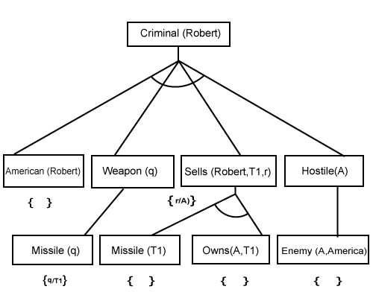

**Conclusion:**

Backward chaining is a powerful technique for goal-driven reasoning, effectively answering specific queries from a knowledge base. It emphasizes the necessity of known facts and rules while focusing on proving desired conclusions.